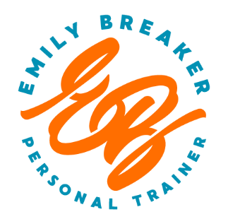
Physical Activity Readiness Questionnaire (PAR-Q)
Name: Date: Date of Birth: Age:
Cell Phone: Email:
Emergency Contact Name: Emergency Contact Number:
Regular exercise is associated with many health benefits, yet any change of activity may increase the risk of injury. Completion of this questionnaire is a first step when planning to increase the amount of physical activity in your life. Please read each question carefully and answer every question honestly.
Yes No Has a physician ever said you have a heart condition or that you should only perform physical activity recommended by a physician?
Yes No When you perform mild physical activity or exertion, do you feel pain in your chest?
Yes No Have you had chest pain in the past month while not engaging in physical activity or exercise?
Yes No Do you ever lose consciousness or lose your balance due to dizziness?
Yes No Do you have a joint or bone problem that could worsen by a change in your physical activity?
Yes No Is a physician currently prescribing medications for your blood pressure or heart condition?
Yes No Are you pregnant?
Yes No Do you have insulin dependent diabetes?
Yes No Are you 69 years of age or older?
Yes No Do you know of any other reason you should not exercise or increase your physical activity?
If you answered yes to any of the above questions, talk with your doctor BEFORE you become more physically active. Tell your doctor your intent to exercise and to which questions you answered yes. If you answered no to all questions, you can be certain that it is safe to gradually increase your level of physical activity. If one of the above answers changes to yes, seek guidance from a physician before continuing with your personal training regimen.
Print Name: _____________________________ Signature: _____________________________
Date: __________
(A parent or legal guardian MUST print and sign if the client is under the age of 18)

